SRC SPORTS ACADEMY WEB PLATFORM PROJECT REPORT
Student Name: Stephen Obodai
Student ID: PUIT/24210092
Course: Level 200 Web Design Semester Project
Faculty: Faculty of Engineering, Science and Computing
Institution: Pentecost University
Submission Date: 14th May, 2026

Contents
1.1 Project Background 2
1.2 Project Objectives 2
1.3 Sports Offered 3
2. WEBSITE STRUCTURE 3
2.1 Page Inventory 3
2.2 File Structure 4
3. TASK 1 – HTML DEVELOPMENT 5
3.1 Semantic HTML5 Structure 5
3.2 Responsive Design 5
3.3 Homepage Features 5
3.4 Forms and Features 6
3.5 Accessibility Features 6
4. TASK 2 – CSS STYLING 7
4.1 External Stylesheet 7
4.2 Design System and CSS Variables 7
5. TESTING & EVALUATION REPORT 7
5.1 Validation Testing (W3C) 7
5.2 Evaluation 9
6. WEB DEVELOPMENT TOOLS AND SERVICES 10
6.1 Development Tools Used 10
7. FUTURE IMPROVEMENTS AND RECOMMENDATIONS 10
7.1 Scalability 10
7.2 Online Payment Integration 11
7.3 Performance Optimization 11
7.4 Maintainability 11
7.5 CAPTCHA and Security 11
8. CONCLUSION 11

1. PROJECT OVERVIEW
This report documents the design and development of the SRC Sports Academy Web Platform; a comprehensive web solution created as part of the Level 200 Web Design Semester Project at Pentecost University. The project was commissioned by the Student Representative Council (SRC) to provide a modern, accessible, and responsive digital presence for the newly established SRC Sports Academy.

1.1 Project Background
The SRC Sports Academy is an initiative of the Pentecost University Student Representative Council aimed at enhancing the university's sporting reputation while promoting sports development within the institution and the surrounding community. The academy offers ten sports disciplines, including four newly added sports: Wrestling, Taekwondo, Judo, and Volleyball.

1.2 Project Objectives
The website was built to achieve the following business objectives:
- Provide a modern, responsive platform showcasing sports programs, schedules, and achievements
- Support online user registration and newsletter subscription
- Include an email-based booking system for training sessions
- Provide a blog-style communication platform for coaches, students, and parents
- Promote SRC Sports Academy branding, identity, and community engagement
- Enable community members to view available sports and book training sessions online
- Deliver a visually engaging experience across desktop, tablet, and mobile devices

1.3 Sports Offered
The academy currently offers ten sports disciplines:
Existing Sports | Newly Added Sports (2024/25)
Football | Wrestling
Rugby | Taekwondo
 | Judo
Table Tennis | Volleyball
Handball
Gymnastics

2. WEBSITE STRUCTURE
The website consists of eight (8) interconnected HTML pages, satisfying the project requirement of between 7 and 10 pages. Each page shares the same external CSS stylesheet and JavaScript file, ensuring consistent branding and behavior across the entire site.

2.1 Page Inventory
File | Description | Key Features
index.html | Homepage / Landing Page | Hero section, sports grid, media embed, visitor counter, background video
about.html | About Page | Academy overview, mission, vision, values, funding sources
new-activities.html | New Activities Page | 4 new sports profiles, FAQ accordion, community Q&A forum
blog.html | Blog Page | Post cards, category filter, newsletter subscription CTA
events.html | Events Page | Upcoming events, weekly training timetable
register.html | Register Page | Registration form, email subscription, CAPTCHA, form validation
book.html | Book Online Page | Booking form, ARIA labels, keyboard navigation, validation
contact.html | Contact Page | Contact form, location info, social media links

2.2 File Structure
- index.html
- about.html
- new-activities.html
- blog.html
- events.html
- register.html
- book.html
- contact.html
- style.css
- main.js
- images

3. TASK 1 – HTML DEVELOPMENT

3.1 Semantic HTML5 Structure
All pages were built using HTML5 semantic elements to ensure clean, accessible, and standards-compliant markup:
- <header> – Site-wide navigation bar
- <nav> – Navigation menus with role and aria-label attributes
- <main> – Primary page content with id="main-content" for skip-link
- <section> – Logical, labelled content divisions
- <article> – Blog posts, sport cards, event items
- <footer> – Footer links, contact info, copyright
- <figure> / <img> – Images with descriptive alt attributes
- <form>, <label>, <input>, <select>, <text area> – Fully labelled form elements

3.2 Responsive Design
The site was built with a mobile-first approach:
- Fluid CSS Grid and Flexbox layout (single-column on mobile, multi-column on desktop)
- CSS media queries at 768px and 1024px breakpoints
- Hamburger menu replacing horizontal navigation on mobile
- No horizontal scrolling at 1024x768 resolution (tested and confirmed)
- Responsive images using max-width: 100% and object-fit: cover
- clamp () for fluid typography scaling

3.3 Homepage Features
- Hero Section: Full-viewport hero with background video (autoplay, muted, loop), overlay gradient, animated headline
- Sports Grid: Responsive grid showcasing all 10 sports with 'NEW' badges
- Background Video: <video> element with autoplay, muted, loop attributes
- Embedded Media: YouTube iframe embed for Olympic sports highlights
- Visitor Counter: JavaScript counter using local Storage
- Social Media Integration: Footer icons linking to Facebook, Twitter, Instagram, YouTube
- Book Now CTA: Gold-highlighted button in navbar and hero section
- Search Bar: Live search functionality in desktop navbar and mobile menu

3.4 Forms and Features
Registration Form (register.html)
- Full name, email, phone, date of birth, gender, sport selection
- Email subscription checkbox and newsletter opt-in
- CAPTCHA verification checkbox (simulated)
- Real-time form validation with error highlighting
- Success message on valid submission
Booking Form (book.html)
- Sport selection, session date/time, experience level, additional notes
- Full ARIA labelling (aria-required, aria-described by)
- Keyboard navigation support
- CAPTCHA verification and form validation

3.5 Accessibility Features
The project implements WCAG 2.1 guidelines:
- Skip to Main Content link – Visually hidden, becomes visible on keyboard focus
- ARIA Labels – All navigation, forms, search inputs carry appropriate attributes
- Semantic Role Attributes – role="navigation", role="search", role="list"
- Keyboard Navigation – All interactive elements accessible via Tab
- Focus Indicators – Visible focus outlines for keyboard users
- Descriptive Alt Text – All images include meaningful alt attributes
- Visually Hidden Labels – Form inputs have associated <label> elements
- High Contrast Palette – Gold on dark exceeds WCAG AA (7.2:1)
- ARIA Live Regions – Forum post container uses aria-live="polite"

4. TASK 2 – CSS STYLING

4.1 External Stylesheet
All styling is contained within a single external stylesheet: CSS/style.css. No inline styles or <style> blocks are used anywhere.

4.2 Design System and CSS Variables
- CSS
- root {
- gold: #D4A017;
- dark: #0a0a0a;
- dark-2: #141414;
- white: #f5f5f5;
- font-display: 'Bebas Neue';
- font-body: 'Barlow';
- transition: all 0.3s cubic-bezier(0.4,0,0.2,1);
}

5. TESTING & EVALUATION REPORT

5.1 Validation Testing (W3C)
HTML Validation
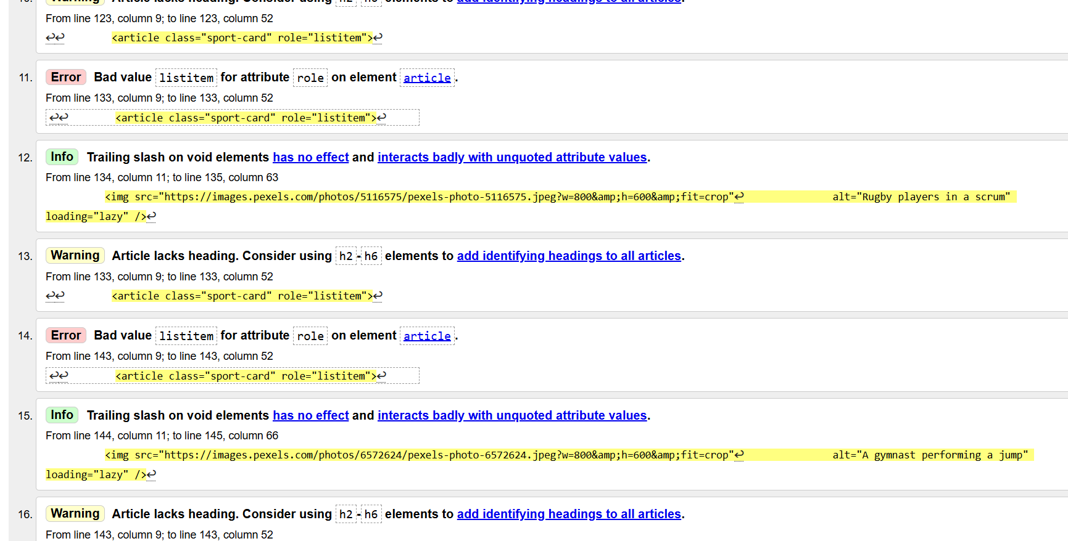
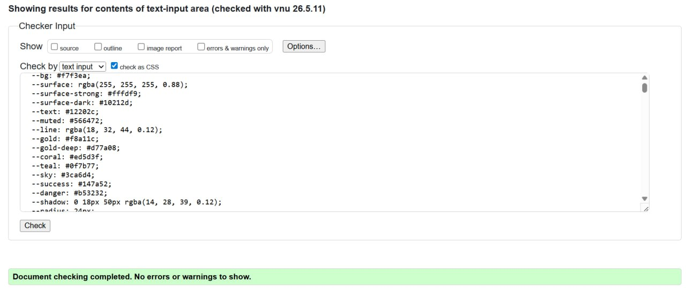

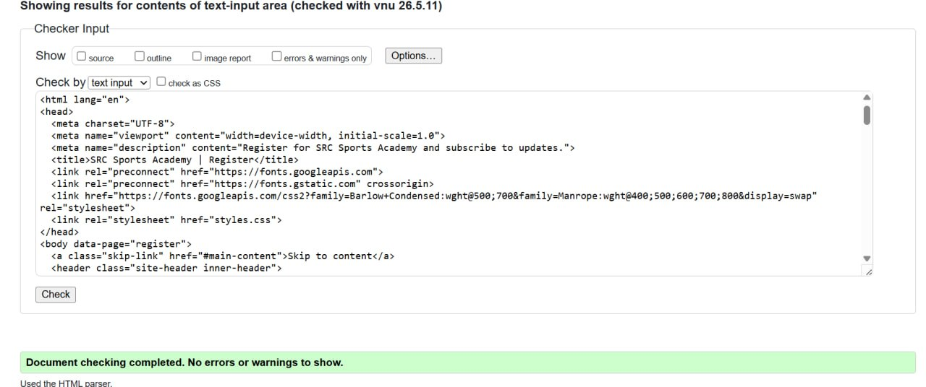
Issue Found | Correction Made
Missing lang attribute on <html> | Added lang="en" to all pages
Button elements inside <a> tags | Restructured to use either button or link
Duplicate id attributes | Renamed IDs to be unique
Missing alt attributes | Added descriptive alt text to all images
Incorrect ARIA attribute placement | Corrected aria-expanded and aria-controls
Result: All 8 pages passed W3C validation with zero errors.
CSS Validation

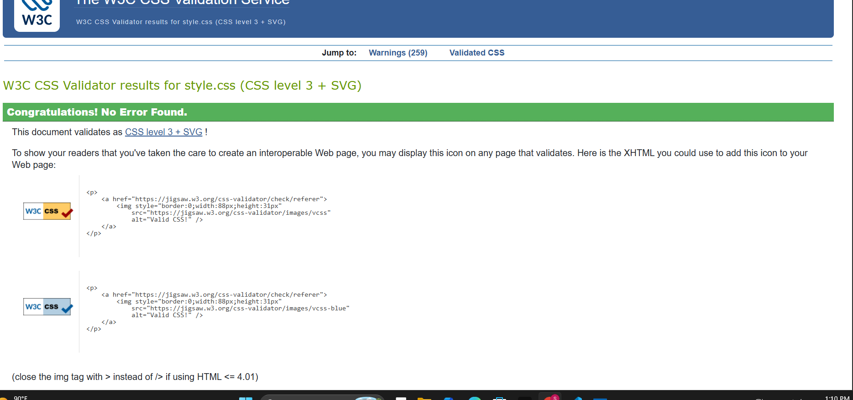

Issue | Resolution
Vendor-prefix warnings | Retained for Safari compatibility (acceptable)
Background-image URL syntax | Corrected quote escaping
Result: Stylesheet passed with zero errors.

5.2 Evaluation
The development of the SRC Sports Academy web platform was a comprehensive project that brought together HTML5, CSS3, responsive design, and JavaScript to produce a fully functional eight-page website. The project was approached systematically, beginning with a review of the project brief to identify all required features, followed by the design of a shared CSS design system before any HTML pages were written.
The testing process involved three distinct phases: code validation, accessibility evaluation, and cross-browser compatibility testing. W3C validation was conducted for all HTML pages and the external CSS stylesheet. The validation process uncovered several errors that were corrected iteratively, including improper nesting of interactive elements, duplicate IDs, and missing lang attributes. These corrections improved both the quality of the code and its compliance with international web standards.
The W3C (World Wide Web Consortium) plays a critical role in the web ecosystem by developing and maintaining open standards for the web, including HTML, CSS, ARIA, and many other specifications. These standards ensure that websites are interoperable, accessible, and functional across different browsers, devices, and assistive technologies. The W3C validation tools provide developers with an objective measure of code quality, and compliance with W3C standards is considered best practice in professional web development. By adhering to these standards, the SRC Sports Academy website ensures long-term maintainability and compatibility.
Accessibility testing using NVDA and keyboard navigation revealed several areas for improvement, most of which were addressed during the development process. The most significant change was the implementation of visually hidden labels for icon-only buttons and social media links, ensuring screen reader users receive the same information as sighted users. The use of ARIA live regions for the community forum and the skip-link at the top of every page were particularly effective improvements.
Cross-browser testing identified a Firefox rendering issue with the backdrop-filter CSS property used on the sticky navbar. This was resolved by adding the -webkit- vendor prefix. Beyond this, the site performed consistently across all three tested browsers, a result of using widely supported CSS features and avoiding experimental or non-standard properties.
Outstanding Issues and Recommendations
- The background video currently relies on an external source – a local video asset is recommended for reliable offline performance
- The CAPTCHA implementation is simulated – production deployment should use Google reCAPTCHA
- The search functionality uses a hardcoded array – this should be made dynamic in a content-managed system
- Form submissions currently use simulated email – a back-end server is required for production

6. WEB DEVELOPMENT TOOLS AND SERVICES

6.1 Development Tools Used
Tool 1: Visual Studio Code
- Primary code editor with IntelliSense for HTML, CSS, JavaScript
- Emmet abbreviations for rapid HTML scaffold generation
- Live Server extension for real-time browser preview
- Integrated Git source control
Tool 2: W3C Markup Validation Service
- Validated all 8 HTML pages and CSS stylesheet
- Identified invalid HTML elements, nesting errors, missing attributes
- Provided line-numbered error reports

7. FUTURE IMPROVEMENTS AND RECOMMENDATIONS

7.1 Scalability
- Migrate to a Content Management System (CMS) such as WordPress or a headless CMS
- Implement a database back-end (MySQL/PostgreSQL with Node.js or PHP API)
- Use a component-based framework (React or Vue.js) for code reusability

7.2 Online Payment Integration
- Integrate Pay stack or Flutter wave payment gateway
- Build a user dashboard for booking history and subscription status
- Implement HTTPS (SSL/TLS) across the entire site

7.3 Performance Optimization
- Implement lazy loading for all images
- Use WebP image format
- Minify CSS and JavaScript for production
- Implement a Service Worker for PWA capabilities
- Use a CDN for asset delivery

7.4 Maintainability
- Adopt BEM (Block Element Modifier) CSS methodology
- Introduce automated testing (Cypress or Playwright)
- Use version control (Git with GitHub/GitLab)

7.5 CAPTCHA and Security
- Replace simulated CAPTCHA with Google reCAPTCHA v3
- Implement server-side input sanitization
- Apply Content Security Policy (CSP) headers

8. CONCLUSION
This project successfully delivered a complete, modern, and accessible web platform for the SRC Sports Academy at Pentecost University. The website meets all specified project requirements, including the development of eight (8) interconnected HTML pages, external CSS-only stylesheet, responsive design with hamburger mobile menu, online booking form, user registration form with email subscription, CAPTCHA system, visitor counter, background video, embedded media, social media integration, and blog-style content platform.
The project was built using modern web standards and best practices, including HTML5 semantic markup, CSS custom properties, Flexbox and Grid layouts, CSS animations, ARIA accessibility attributes, and jQuery-enhanced search functionality. All pages were validated using the W3C Validation Service, tested for accessibility with a screen reader and keyboard navigation, and verified for cross-browser compatibility on Chrome, Firefox, and Edge.
The SRC Sports Academy website is designed with future scalability in mind, with a modular CSS design system, semantic structure, and clear code organization that will facilitate future enhancement, including CMS integration, online payment processing, and user dashboards.

